Project Asclepius - A study of breakthrough therapy designated drugs market

# *with a focus on Insurance coverage in Cancer therapy area

Priyadarshani Amrut Ghorpade Sayali Narayan Mahamulkar

*M.S. in Business Analytics M.S. in Business Analytics*

*California State University East Bay California State University East Bay*

Hayward, California Hayward,California [pghorpade@horizon.csueastbay.edu](mailto:pghorpade@horizon.csueastbay.edu) [smahamulkar@horizon.csueastbay.edu](mailto:smahamulkar@horizon.csueastbay.edu)

***Abstract*—**

**This project aims to find the gap between breakthrough therapies and the availability of benefits to patients through insurance providers. This project will describe an analytical study of historical data on breakthrough therapies since they were approved by FDA. We will also track the expenses from the past that a patient has to bear and which are not covered by insurance providers.**

***Keywords: Insurance, breakthrough therapies, FDA, medical expenses, etc.***

# I. INTRODUCTION

Breakthrough Therapy designation is a process designed to expedite the development and review of drugs that are intended to treat a serious condition if preliminary clinical evidence indicates that the drug may demonstrate substantial improvement over available therapy on a clinically significant endpoint(s) [2].

In the past few decades, with an improved understanding of the genomic and immunologic underpinnings of cancer, better molecular characterization of tumors, and more precisely targeted agents, new and innovative therapeutics have altered the natural histories of certain cancer types [3]. This has opened doors to more potential breakthrough therapies/drugs. These therapies involve a high amount of research cost resulting in higher amounts of therapy for patients and insurance service providers.

# II. PROJECT GOAL

## *A. Problem Statement*

Very few breakthrough therapies are covered by insurance providers due to the smaller patient pool. These are high-cost drug therapies and despite the efforts from FDA to bring these therapies to market via Fast-track approval methods, payer response has been less than ideal. We see a lot of online petitions and fundraisers for patients with rare and orphan diseases who cannot afford these new and high-end drug therapies which cost a lot of money and are also not covered under many insurances[9].

## *B. Solution*

## In this study, we want to figure out the gap between actual patients in these indications(life-threatening illnesses) who require breakthrough therapies and the benefits received from insurance providers such as Medicaid /Medicare. We want to analyze data of breakthrough therapies since their FDA approval and patients who have benefited from these therapies. Next, we want to analyze the expenses by insurance providers for these therapies today. With the help of a Tableau dashboard, we have visualized the results of the above exercise as well as a further study where patients can receive funding in the coming years.

## *C. Scope*

We currently have a list of 250 breakthrough therapies approved by the FDA since 2012 in 5 categories of disease groups. The current focus of the project is on the U.S. population and healthcare service providers(Insurance payers). We aim to achieve an analytical study of coverages available for different diagnostics.

# III. BACKGROUND

1. *What are breakthrough therapies?*

A breakthrough therapy designation is for a drug that treats a critical condition and preliminary clinical evidence tells us that the drug may demonstrate substantial improvement on a clinically significant endpoint(s) over other available therapies. This is basically a fast-track process for drug approval. By priority review, the overall time of FDA Review of about 10 months comes down to 6 months[16].

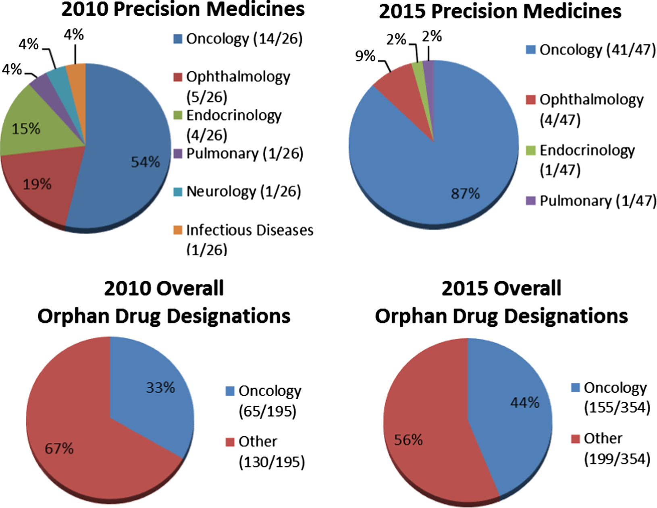

Fig 1: Precision Medicines and Drug Designations from 2010 to 2015[17].

The above image shows a significant difference in Precision Medicines and Orphan Drug Designations which is particularly spiking for Oncology in a period of 5 years.

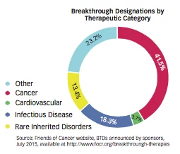

Fig 2: Breakthrough Designations by Therapeutic Category

1. *What is a drug formulary?*

A formulary is a list of generic and brand-name prescription drugs covered by your health plan. Your health plan may only help you pay for the drugs listed on its formulary. It’s their way of providing a wide range of effective medications at the lowest possible cost.

1. *What is Incidence Data?*

Incidence is the change in occurrences observed in disease over a specific period of time. This can be in terms of new cases of the disease or injury in a population over a specific period of time. It is the number of newly diagnosed cases of a disease. Some epidemiologists use the incidence data to mean the total of new cases per unit of the population.

An example of incidence can be about 795,000 new strokes in a year in the United States.

1. *What is Prevalence Data?*

Prevalence is a measure of a disease that allows us to find a person's chances of having a disease. Thus, the number of prevalent cases is the total count of cases of disease existing in a population.

The best example of prevalence can be the prevalence of obesity in the US population of adults in 2001 which was estimated by the U. S. CDC at about 20.9%.

1. *What are tiers of Formulary Data?*

A health plan’s formulary is divided into three or four categories. These categories are called tiers. Drugs are placed in tiers based on the type of drug: generic, preferred brand, non-preferred brand, and specialty. Here’s what typical formulary tiers look like:

Tier 1: Tier 1 drugs are usually generics and have the lowest copays.

Tier 2: Tier 2 drugs will cost you more than tier 1 medications. They include non-preferred generics and brand-name medications.

Tier 3: Tier 3 includes generics, preferred brands, and non-preferred brands. Your out-of-pocket price for these drugs will be higher than tiers 1 and 2. Your health plan may place a drug in tier 3 if it’s new or if there's a similar drug on a lower tier.

Tier 4: Tier 4 includes generics, preferred brands, non-preferred brands, and specialty drugs. Specialty medications treat rare or serious medical conditions. Your out-of-pocket cost will be highest in tier 4.

Tier 5: Tier 5 includes the non-preferred type of drugs. Such types of drugs usually have a preference of brand by patients available in the market.

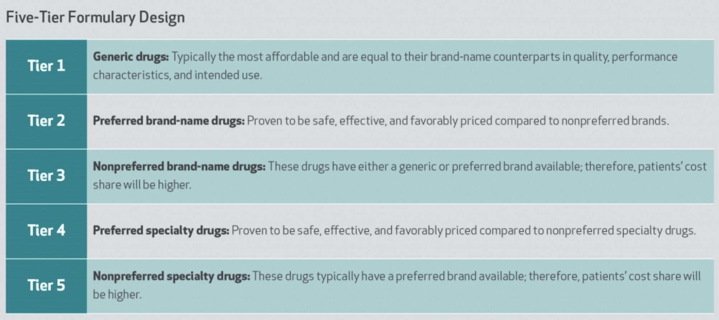

Fig 3: Five Tier Formulary Design

A closer look at the insurance company’s formularies for each of their plans suggests that a company may list a drug from tier 1 in one plan, but from tier 2 in another plan. What’s more, don’t assume a tier 1 drug for a certain insurance company will be listed as a tier 1 drug for all insurance companies. The same drug can be found on different tiers from one insurance provider to another[24].

1. *How are tiers created and why do they change?*

Typically, a team of medical professionals approves the drugs on a health plan’s formulary based on safety, quality, and cost-effectiveness. The team is made up of pharmacists and physicians who review new and existing medications.

Sometimes health plans choose not to cover a prescription drug. They do this if:

* The drug has a generic version.
* The drug is considered less effective than other, similar drugs.
* The drug is as effective as other, similar drugs but costs much more.

Health plans update their formularies every year, but they also make changes throughout the year. These changes occur when a new drug becomes available or when the FDA decides a drug is harmful.

1. *Organization of Health System in the United States*

The U.S. health system has a mix of public and private provisions of health care, for-profit and nonprofit insurers, and health care providers. The federal government has provisions for people above 65 years of age, children, and people with some disabilities under the national Medicare program.It also has different programs for veterans[15].

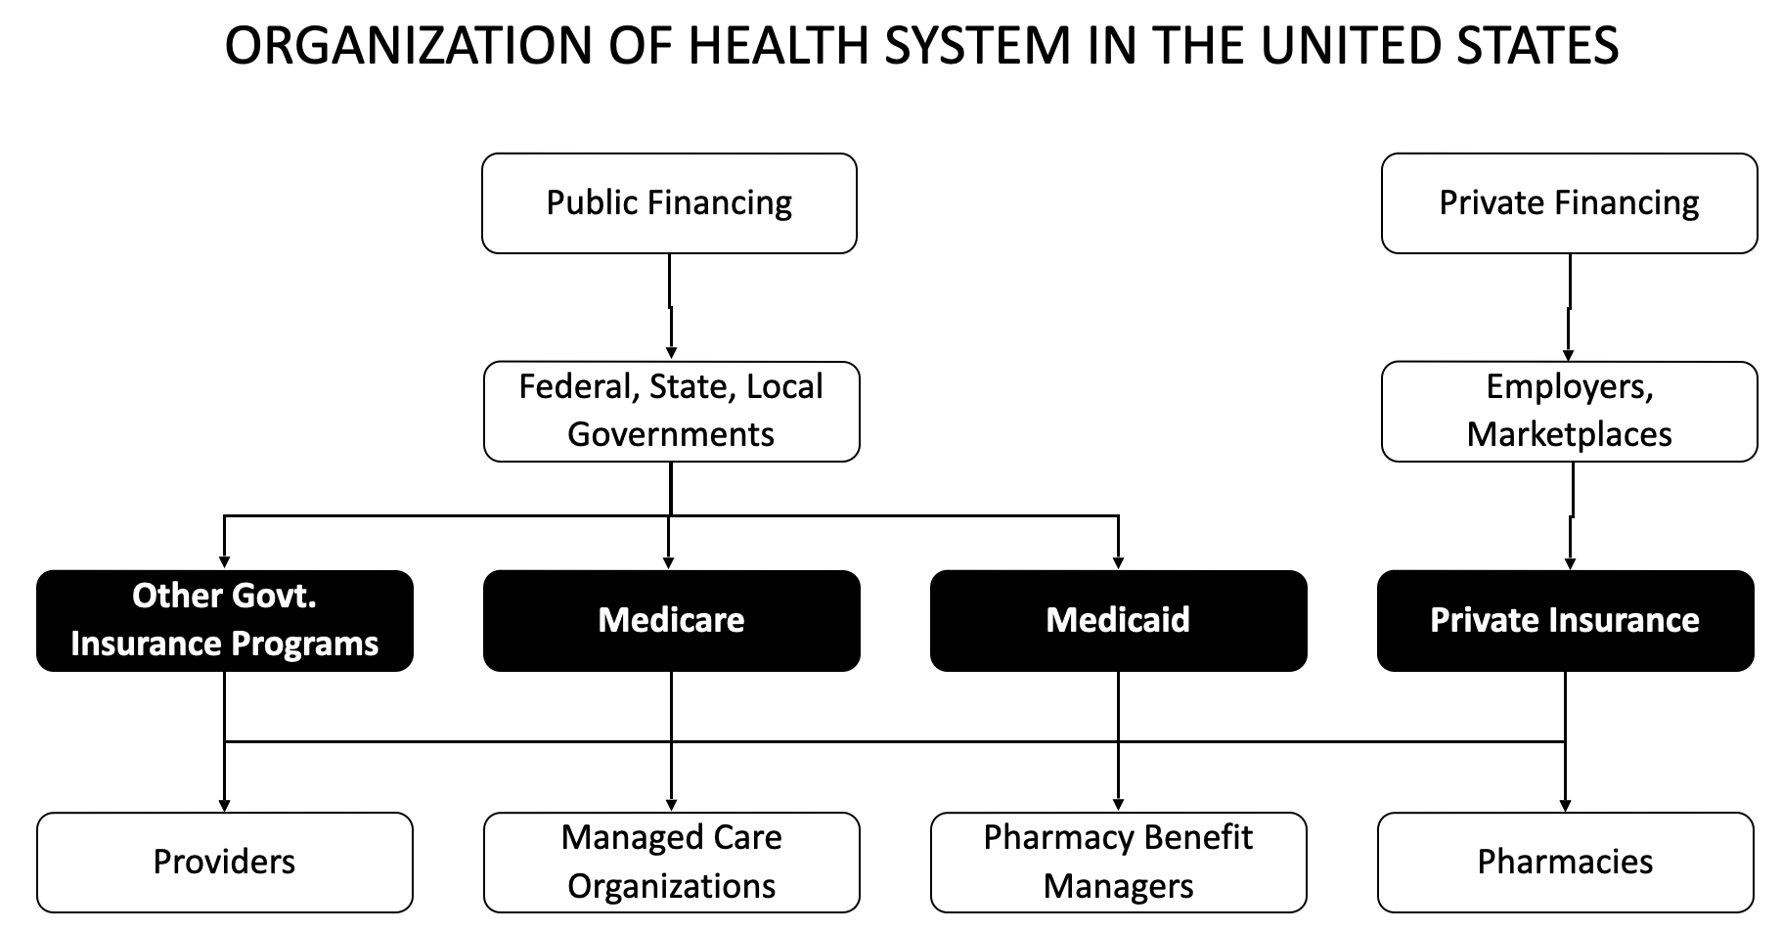

Fig. 4: Organization of Health System in the US

1. What are ICD 10 Codes?

The ICD-10-CM (International Classification of Diseases, Tenth Revision, Clinical Modification) is a system used by physicians and other healthcare providers from the HealthCare domain to classify and code all diagnoses, symptoms, and procedures recorded in association with hospital care in the United States of America. These codes are a reference for a particular disease and are also used by Insurance providers[25].

# IV. DATA AND DATASETS

1. BREAKTHROUGH LIST

We obtained a list of breakthrough designations granted and approved drugs from the FDA’s official website as a starting point for our analysis. This list contains the following attributes.[2]

| **Variable Name** | **Description** | **Data Type** |
| --- | --- | --- |
| Trade Name (Agent) | Combination of Brand Name and Generic Component name in brackets | String |
| Sponsor | Name of the companies sponsoring the trials and launch | String |
| Date of BT Designation Disclosure | When the drug was designated breakthrough drug based on preliminary trials | Date |
| Approval Date | When the drug received FDA approval and launched | Date |
| Indication | Details of the disease for which the drug was approved | String |
| Category | Category of the disease e.g. Cancer or Cardiovascular | Object |
| FDA Status | FDA approval status(Granted or rescinded) | Object |

Table 1: FDA approved Breakthrough designation drugs

1. COVERAGE DATA FROM VARIOUS PROVIDERS[20]

We managed availing data from a Data provider company Managed Markets Insight & Technology, LLC. upon email request. This was raw data that consisted of Coverage status and the number of plans by each insurance provider/payer/PBM for the list of drugs we obtained above.

| **Variable Name** | **Description** | **Data Type** |
| --- | --- | --- |
| Payer/PBM | Name of the payer/PBM / State for State Medicaid table | string |
| # of Plans | Total no. of plans provided by Payer | int |
| Drug Name1 | % of Plans covered by the Payer for Drug 1 and Coverage status | string |
| Drug Name 2 | % of Plans covered by the Payer for Drug 1 and Coverage status | string |

Table 2: Raw data information

We have 5 such tables each with coverage data for Commercial, Medicare, State Medicaid, Health Exchange and Managed Medicaid.

The coverage status has 5 values as below

| Not Covered | Drug is not covered(Drug is not in the formulary) |
| --- | --- |
| Covered (PA/ST) | Covered with some restrictions(Drug is present in tier 2) |
| Covered | Covered without restrictions(Drug is present in tier 1) |
| Preferred (PA/ST) | Preferred with restrictions |
| Preferred | Preferred without restrictions(the drug is present in tier 3 and above) |

Table 3: Coverage Status details

PA - Prior Authorization

It is a requirement needed for a prescriber to receive pre-approval for prescribing a particular drug to get the medication coverage under the terms of the pharmacy benefit plan[22].

ST - Step Therapy

Step therapy is a type of prior authorization. In most cases, you must first try a less expensive drug on the Drug Plan's formulary that has been proven effective for most people with your condition before you can move up a “step” to a more expensive drug

QL - Quantity Limitation

Quantity Limits (QL) are a drug utilization management tool limiting the amount of a particular drug that the insurance plan will cover during a specified time period, such as 30 pills per 30 days.

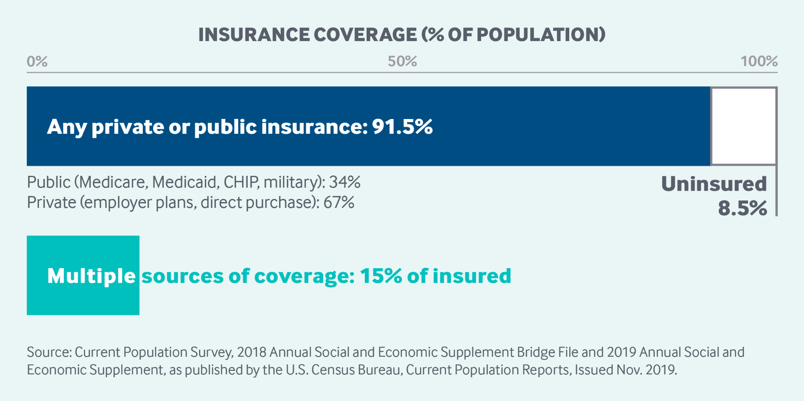

Fig. 5: Insurance coverage[21]

Above graph indicates that the major population in the US is covered by Commercial(Private), Medicare, or State Medicaid. Hence we will use only these 3 tables for our analysis.

# V. DATA ANALYSIS APPROACH

Data preprocessing is an important process as we have some data which has null values and data based on other breakthrough therapies. We aim to follow the following steps:

A. DATA COLLECTION:

We are filtering data on the basis of 2 attributes. These include Approved Therapies and Cancer data. There is mass data that is available and has data for approved as well as unapproved therapies.

1. DATA PREPROCESSING:

From the list of breakthrough therapies, we filter the column ‘Approved date’ to select only the therapies that have received approval from FDA for launch. These are a total of 251 Breakthrough therapies with FDA approval.

Since it is easier to find the Epidemiology and coverage data for indications under Cancer Category, we filter the Category Column to get a total of 142 breakthrough therapies.

1. DATA MANIPULATION:

Though data deduplication causes loss of data integrity at certain times, we are deduplicating data for redundancy. Some data is removed for obtaining optimal results.

There are many repetitions in the list since a single drug could be approved for multiple therapeutic indications in the same category. E.g. AstraZeneca’s brand Calquence received the breakthrough designation for 2 different types of Cancer treatments. Hence this list comes down to a total of 82 drugs. Still, we find few combination drugs that repeat in the data we are keeping these rows for our analysis.

1. DATA OVERVIEW:

After manipulating the raw data, we processed the data frames. Since the data has two components merged in the same field in the coverage files, we split each of these tables into 3 separate data frames to generate excel files which were then used to visualize and analyze data.

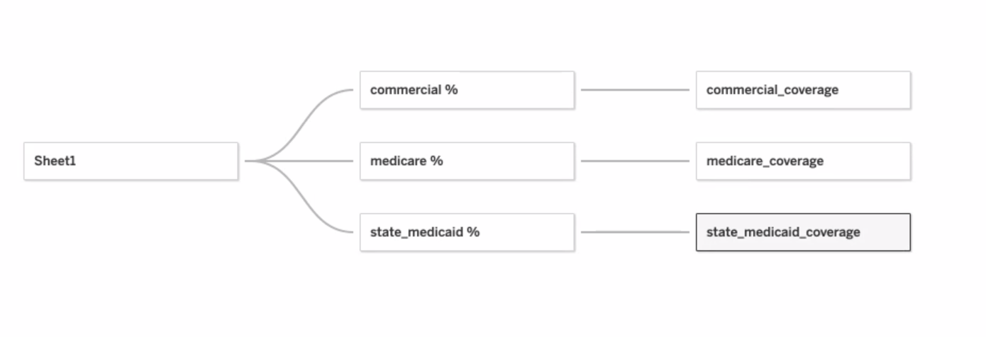

Fig. 6: Data tables used and their connectivity

The 3 separate data frames are described as below:

1. Commercial % and Coverage:

Commercial data was preprocessed using python programming language and after performing the ETL process on it, the fig. 9 data was converted into tables in excel files which were then loaded on Tableau to generate visualizations of the analysis performed on the data.

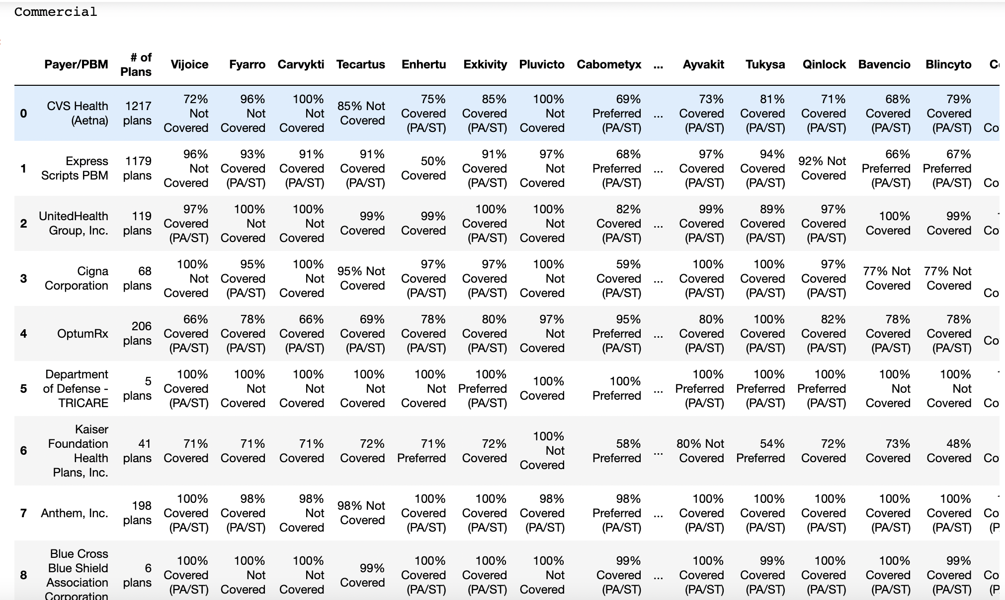

Fig. 7: Commercial Data before processing

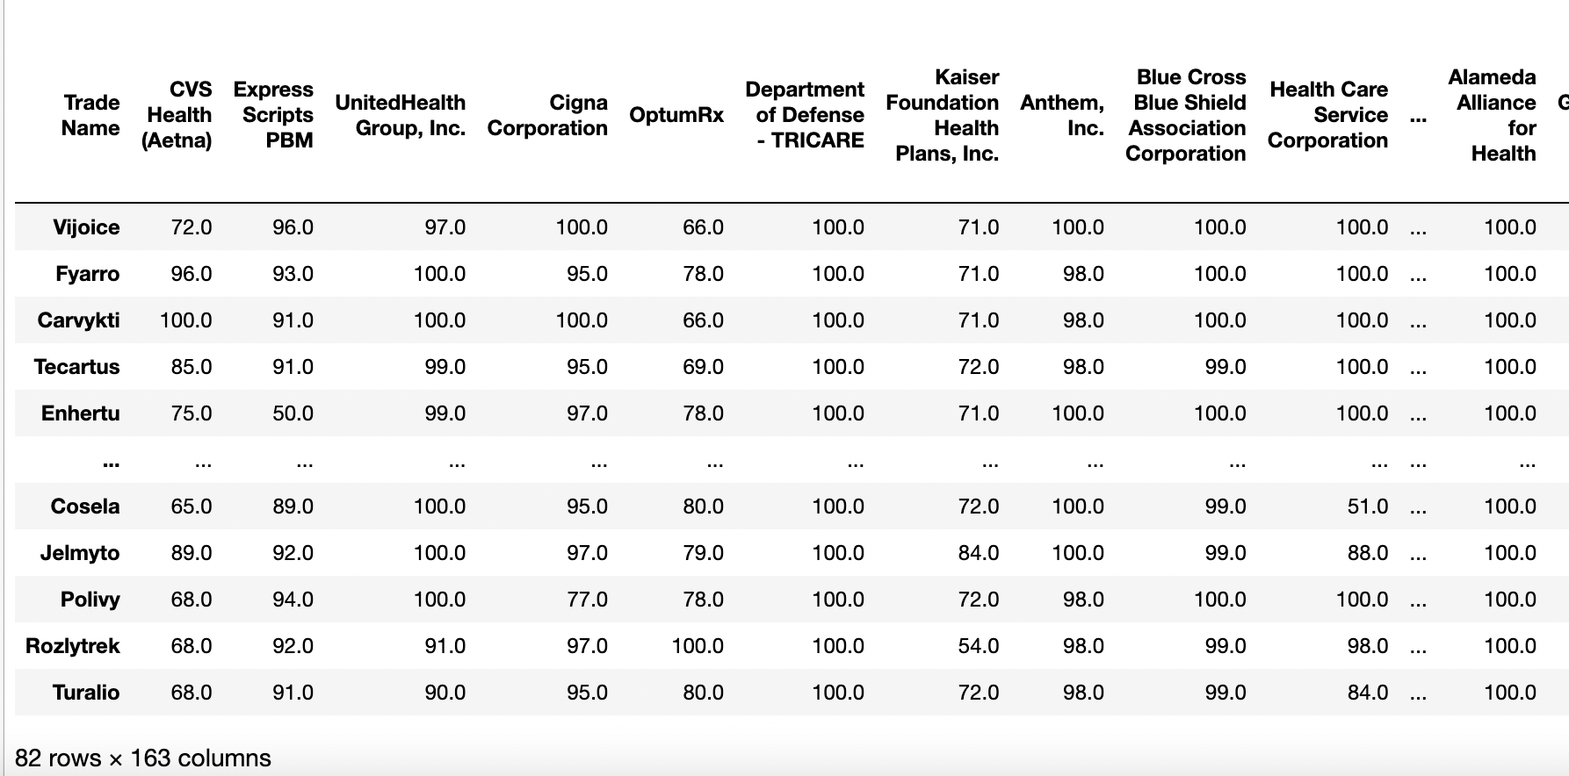

Fig. 8: Commercial % Data after processing

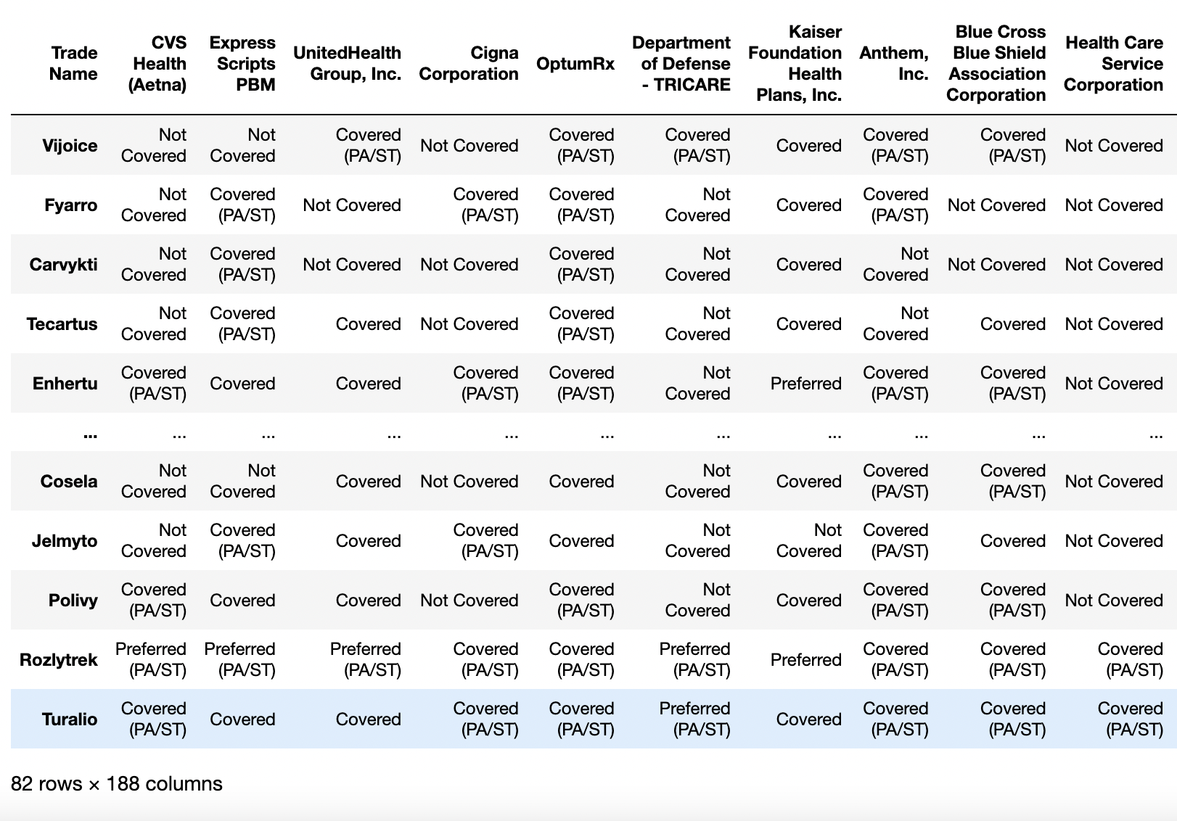

Fig. 9: Coverage Status of Commercial Data after processing

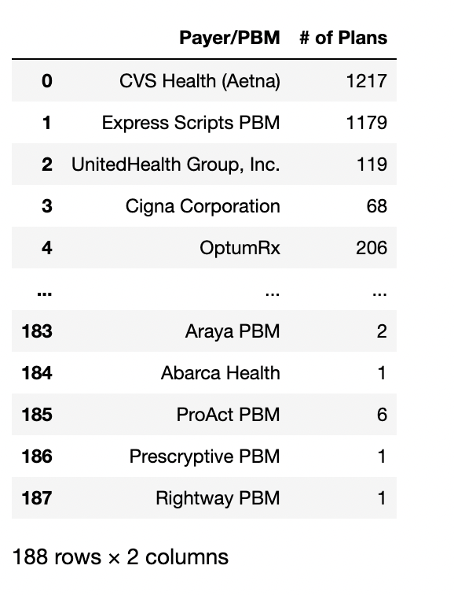

Fig. 10: Number of Plans by each Payer/PBM of Commercial Data

1. Medicare % and Coverage:

Medicare data which is also known as health services utilization data, is collected by the Centers for Medicare and Medicaid Services (CMS) and then, it is derived from reimbursement information or the payment of bills by consumers/ patients.

Medicare data was preprocessed using python programming language and after performing the ETL process on it, the fig. 13 data was converted into tables in excel files which were then loaded on Tableau to generate visualizations of the analysis performed on the data.

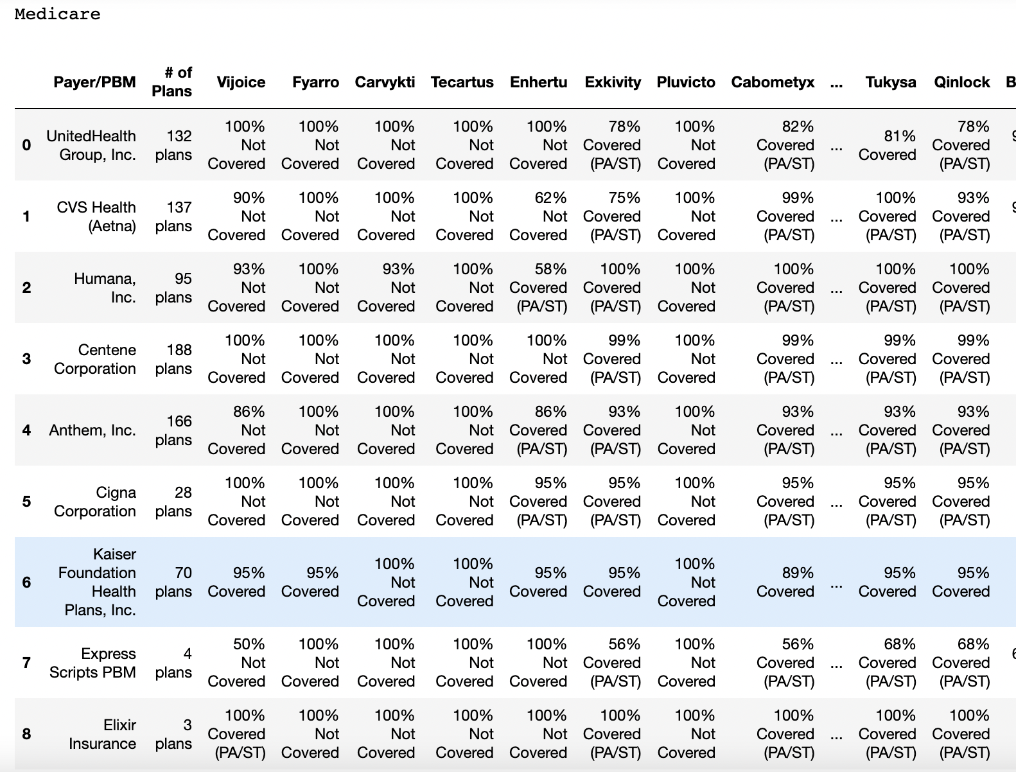

Fig. 11: Medicare Data table before processing

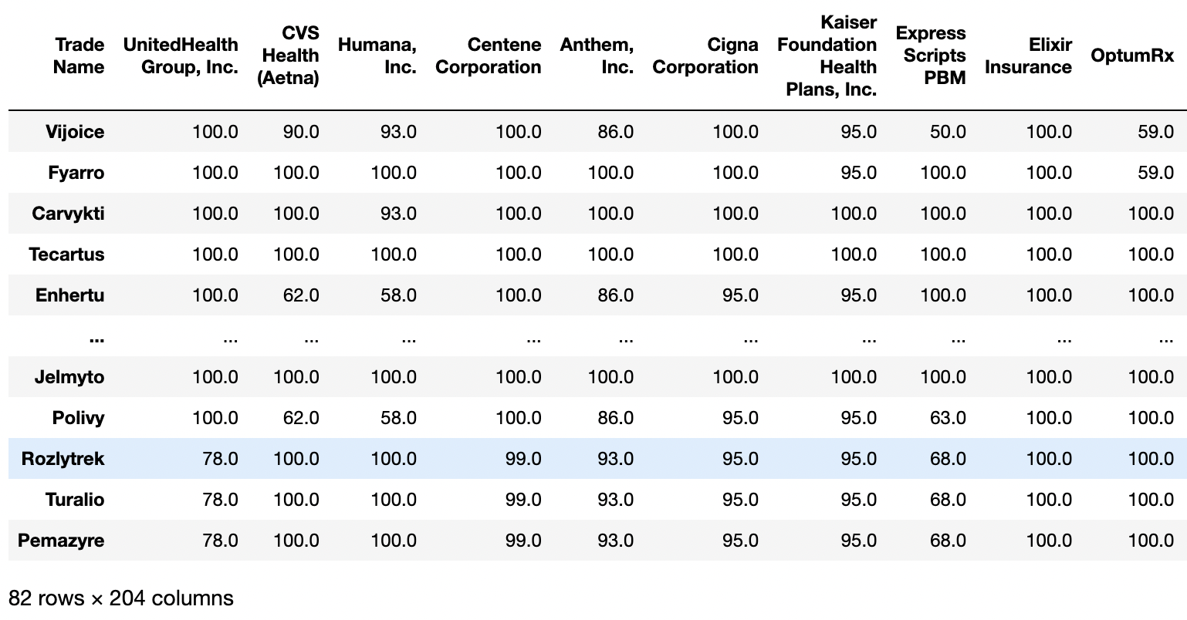

Fig. 12: Medicare % Data table after processing

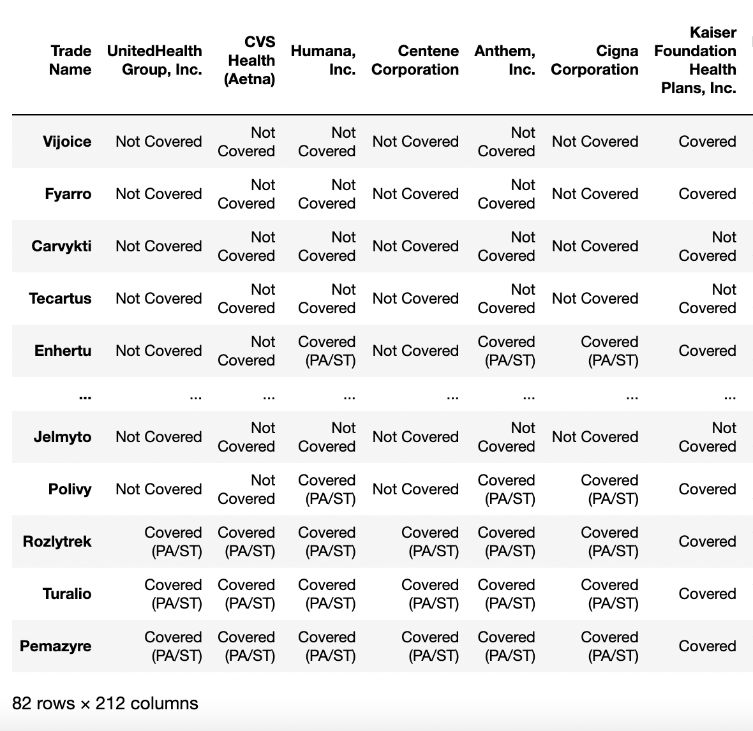

Fig. 13: Coverage Status of Medicare Data table after processing

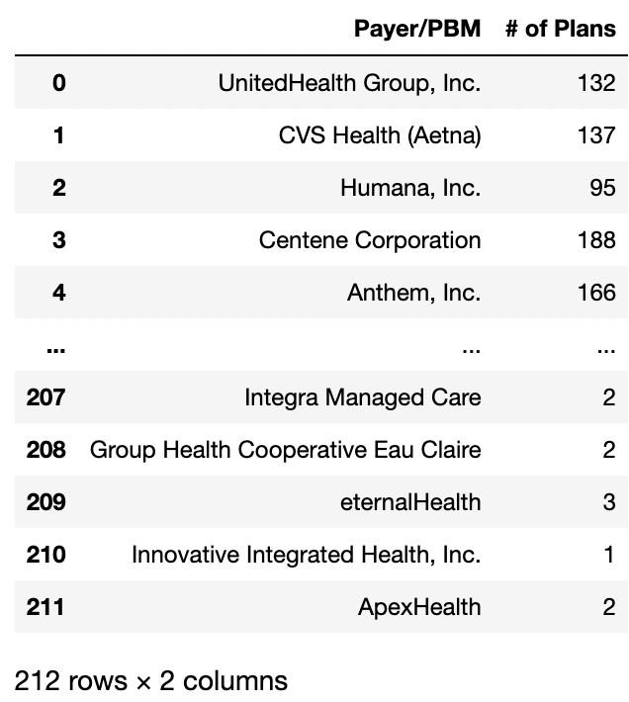

Fig. 14: Number of Plans by each Payer/PBM of Medicare Data

1. State Medicaid % and State Medicaid Coverage:

State Medicaid data is a set of person-level data that is derived from MSIS data on Medicaid eligibility, service utilization and payments.

Medicare data were preprocessed using python programming language and after performing the ETL process on it, the fig. 16 data was converted into tables in excel files which were then loaded on Tableau to generate visualizations of the analysis performed on the data.

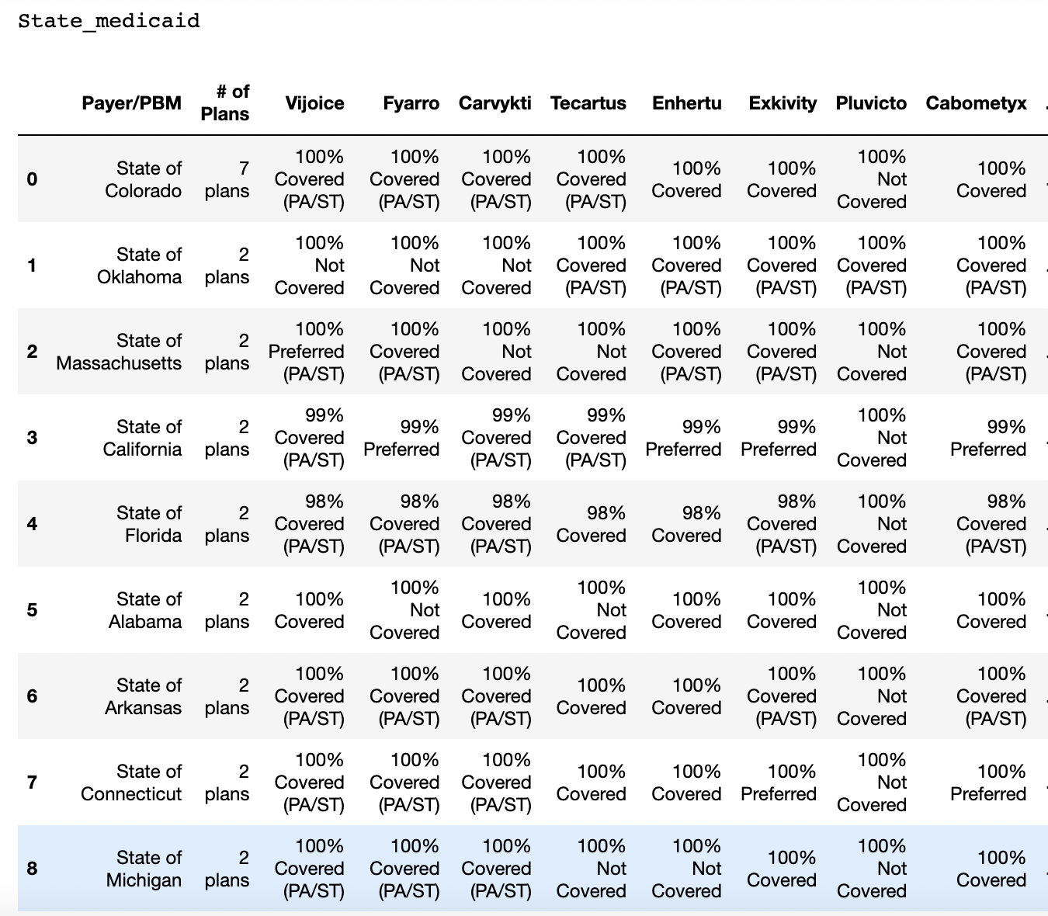

Fig. 15: State Medicaid Data before processing

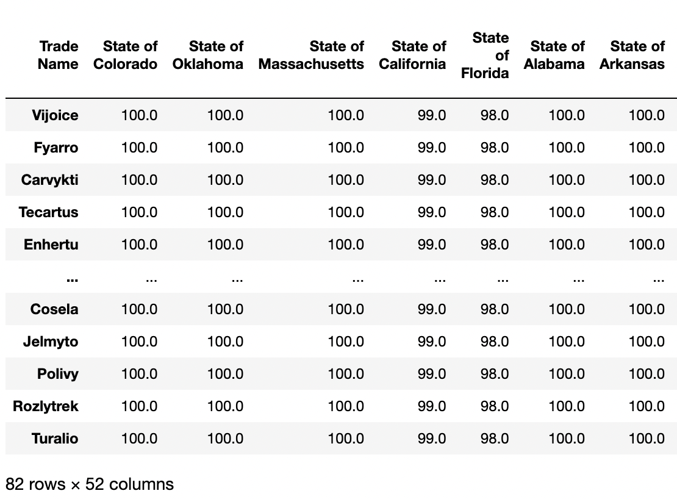

Fig. 16: State Medicaid % Data post-processing

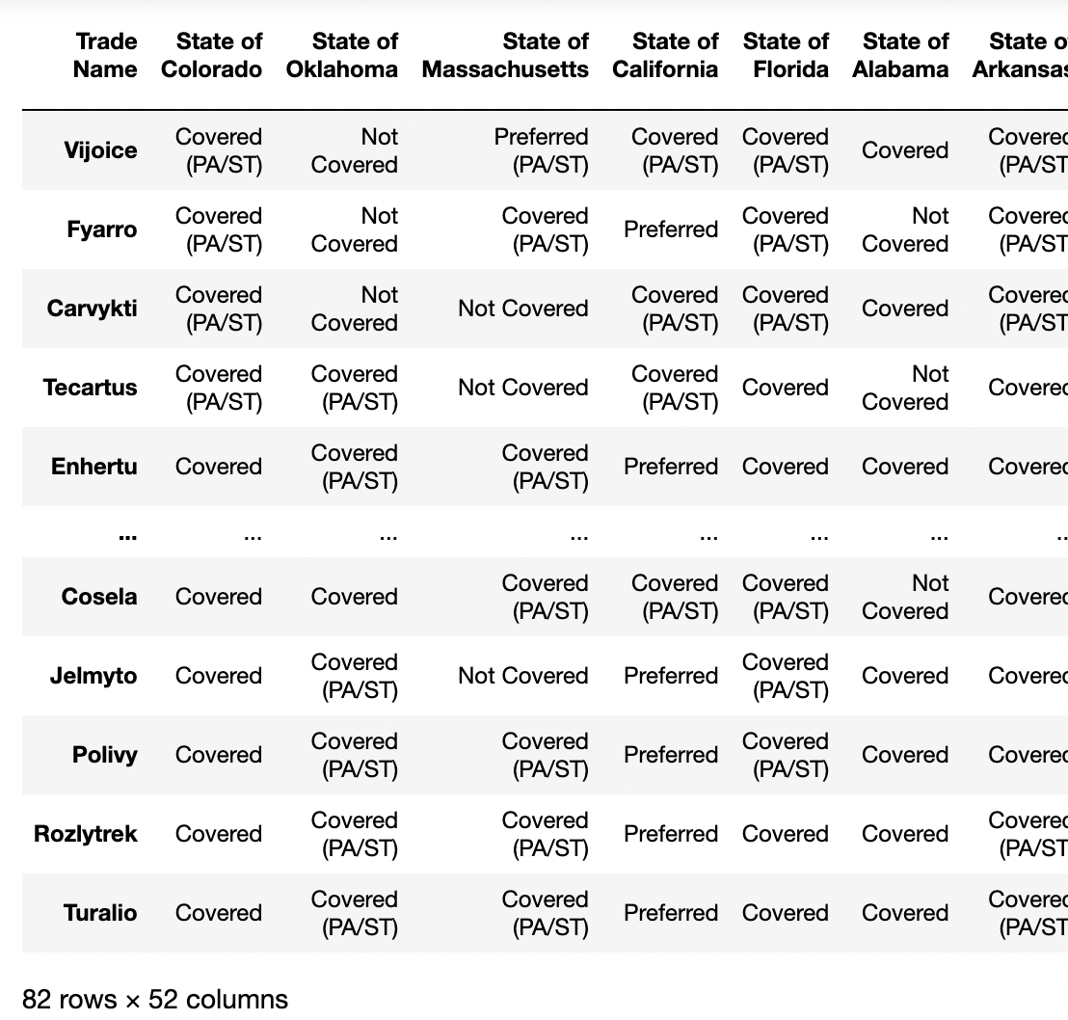

Fig. 17: Coverage Status of State Medicaid Data post-processing

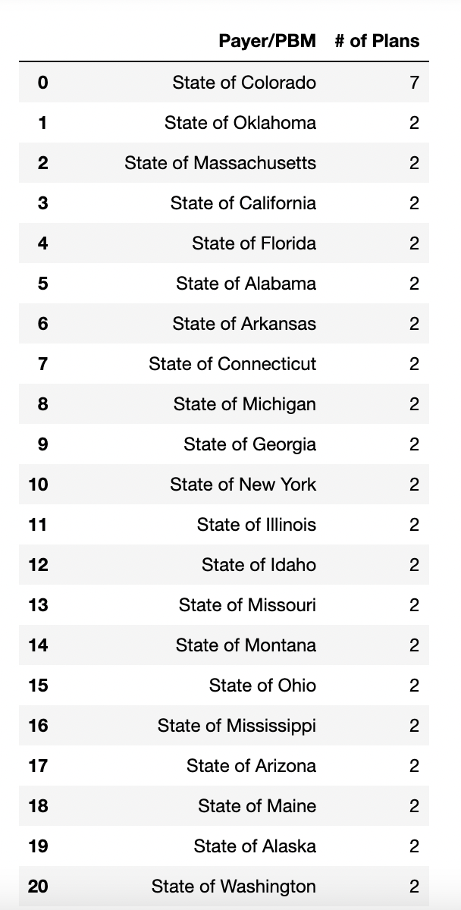

Fig. 18: Number of Plans by each Payer/PBM of Medicare Data

1. Health Exchange

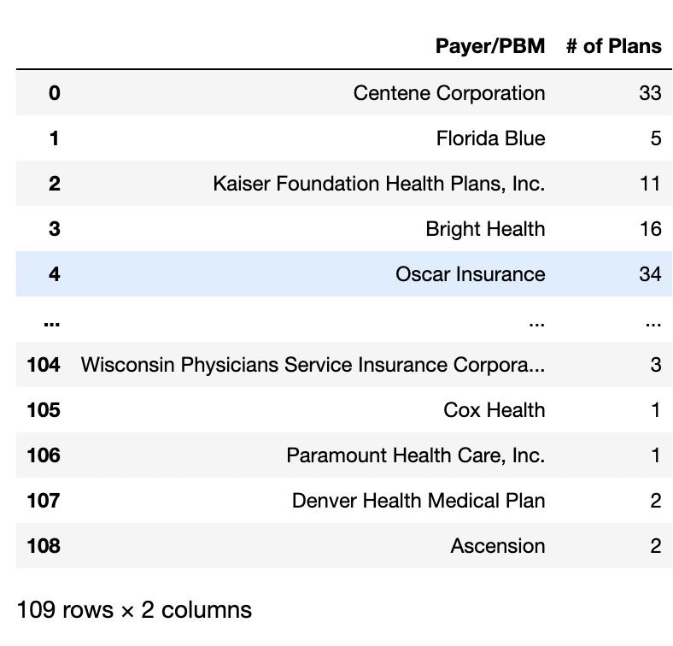

Fig. 19: Number of Plans by each Payer/PBM of Health Exchange Data

1. Managed Medicaid

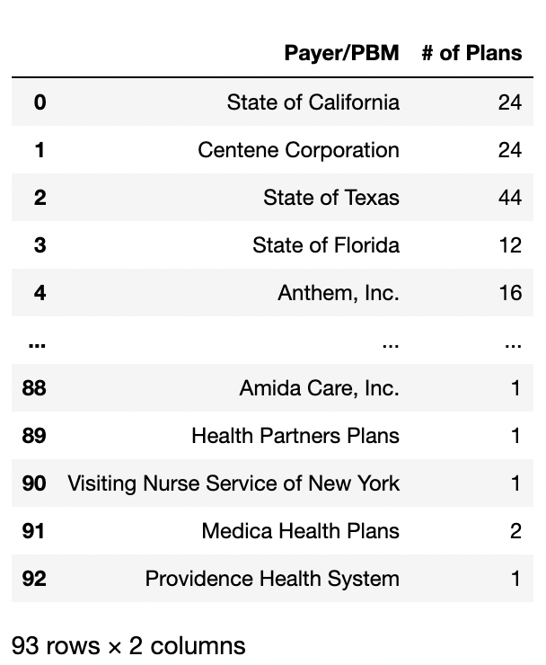

Fig. 20: Number of Plans by each Payer/PBM of Managed Medicaid Data

1. ETL PROCESS:

The data extracted from the formulary lookup website was preprocessed to remove null values and unwanted data using jupyter notebook and Microsoft Excel tools. The transformed data were then used to generate the following

1. DATA VISUALIZATION:

Null values data has not been handled yet but we aim to drop columns that have multiple null values and are not of much importance. For rows that have some null values, we are replacing them with a mean or median, or constant value.

# VI. DATA VISUALIZATION

### Sponsoring Companies

This graph gives information about companies that have been sponsors for most drugs that are approved by FDA. The darker the color assigned for a company, the more the number of FDA-approved drugs are sponsored by that company.

### 

Fig. 21: Sponsoring Companies Visualization

1. Therapy Areas

This graph shows the areas of Therapy which are Cancer, Cardiovascular, Infectious Diseases, Rare Inherited Disorders, and all other diseases.

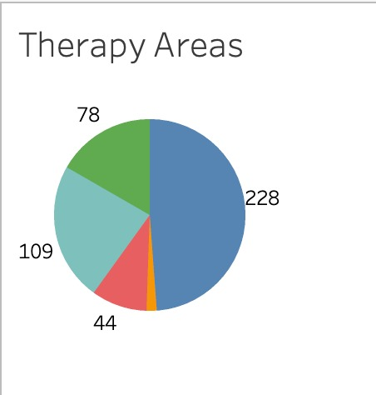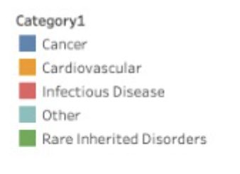

Fig. 22: Therapy Areas

1. Breakthrough Designations and Approvals every year

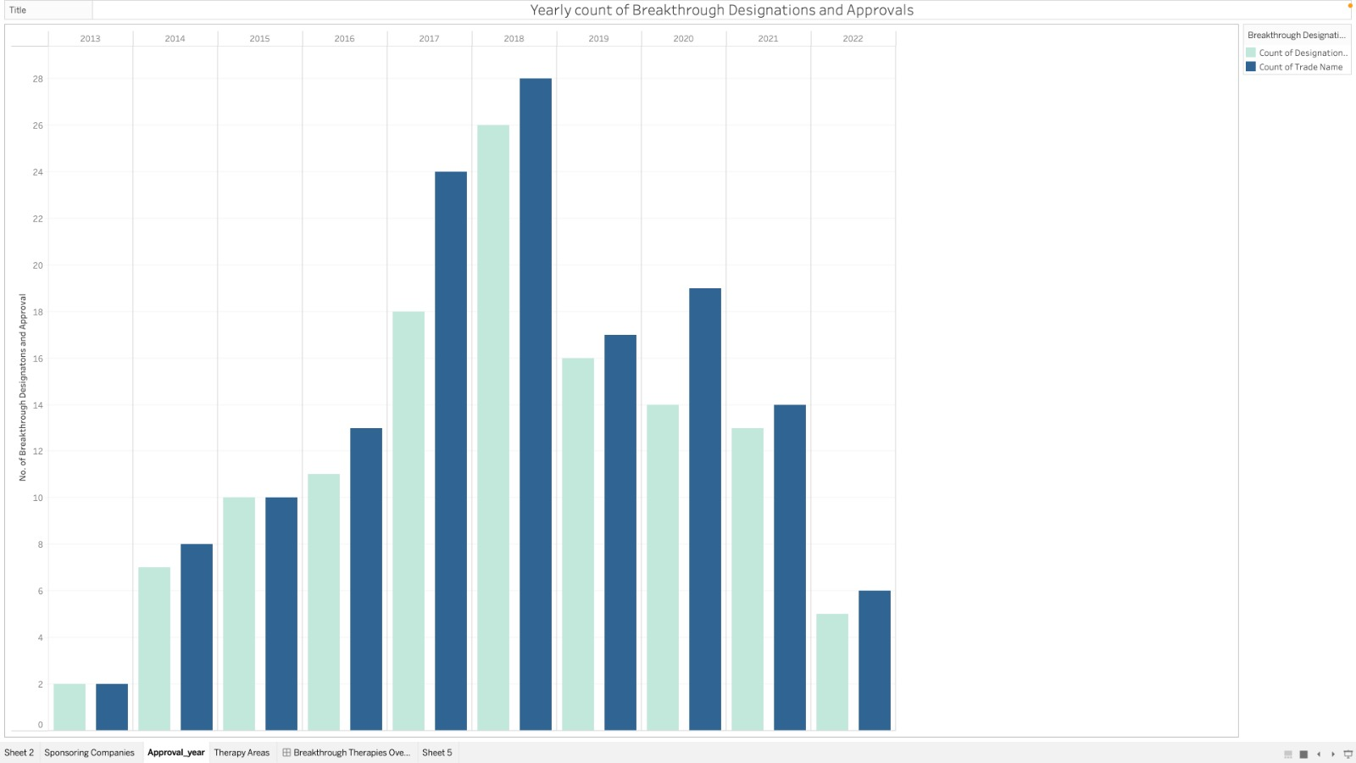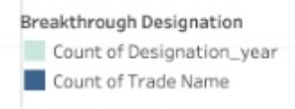

Fig. 23: Yearly count of Breakthrough Designations and their approval rate by FDA

1. Coverage by Payers/PBMs

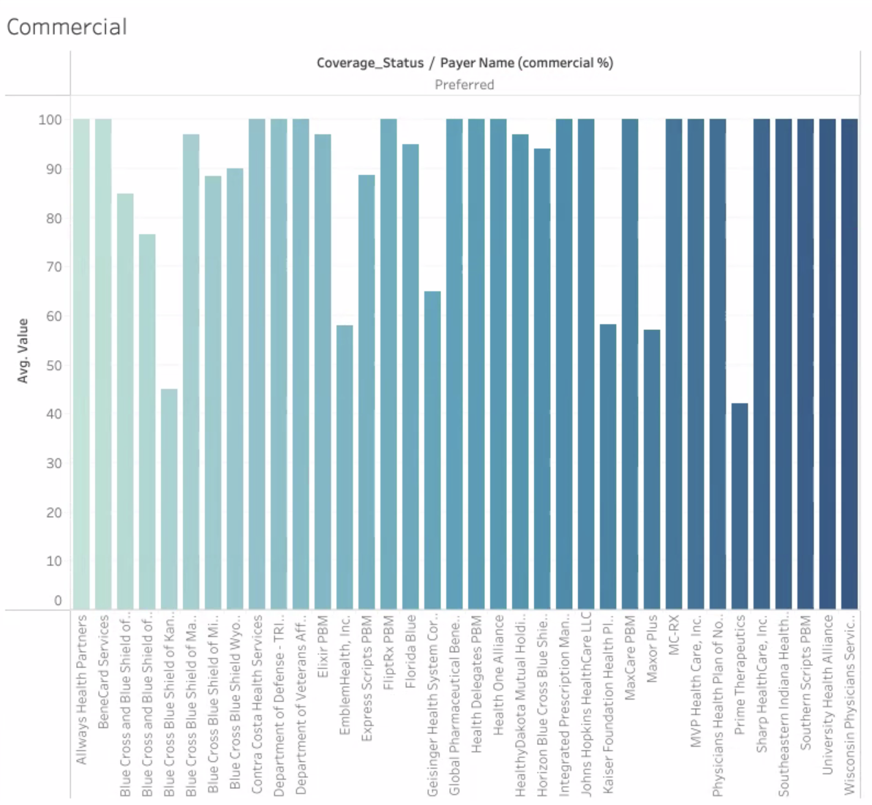

Fig. 24: Coverage Status of Payers

1. Count of drugs coverage by Payers/PBMs

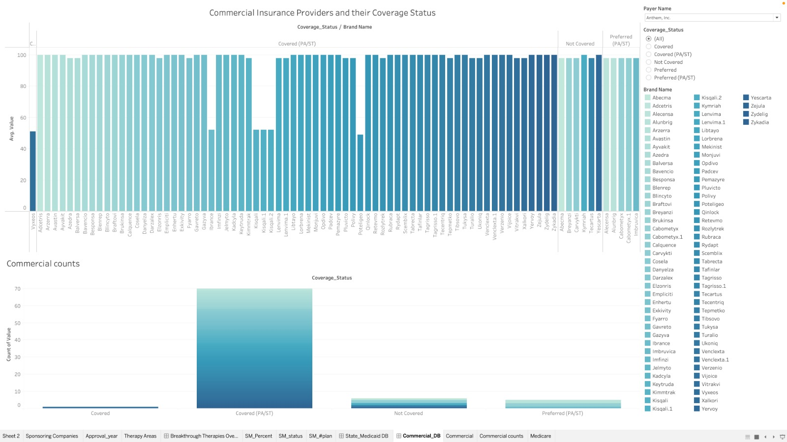

Fig. 24: Commercial Coverage Status of Payers

VII. ANALYSIS

1. Top Coverage and No Coverage Providers:

The Cosela Brand which has Cosela to G1 Therapeutics as its sponsor is top most covered.

Pluvicto by Novartis Pharmaceuticals tops for not covered.

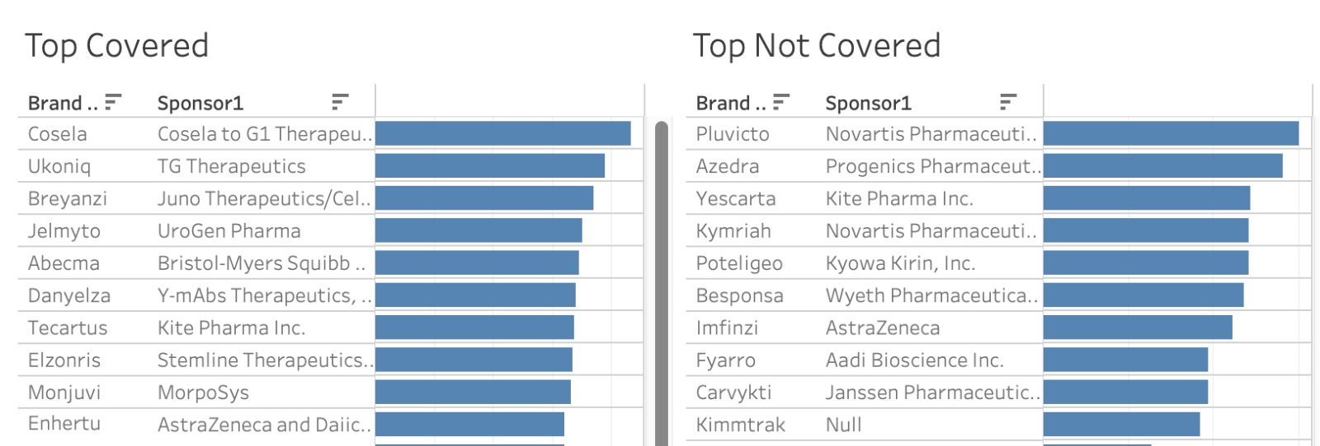

Fig. 24: Top Coverage and No Coverage Status of Payers

1. Highest and Least Coverages provided by Payers/PBMs:

Wisconsin has the highest coverage value as per State Medicaid Coverage.

Tennessee has the lowest coverage value as per State Medicaid Coverage.

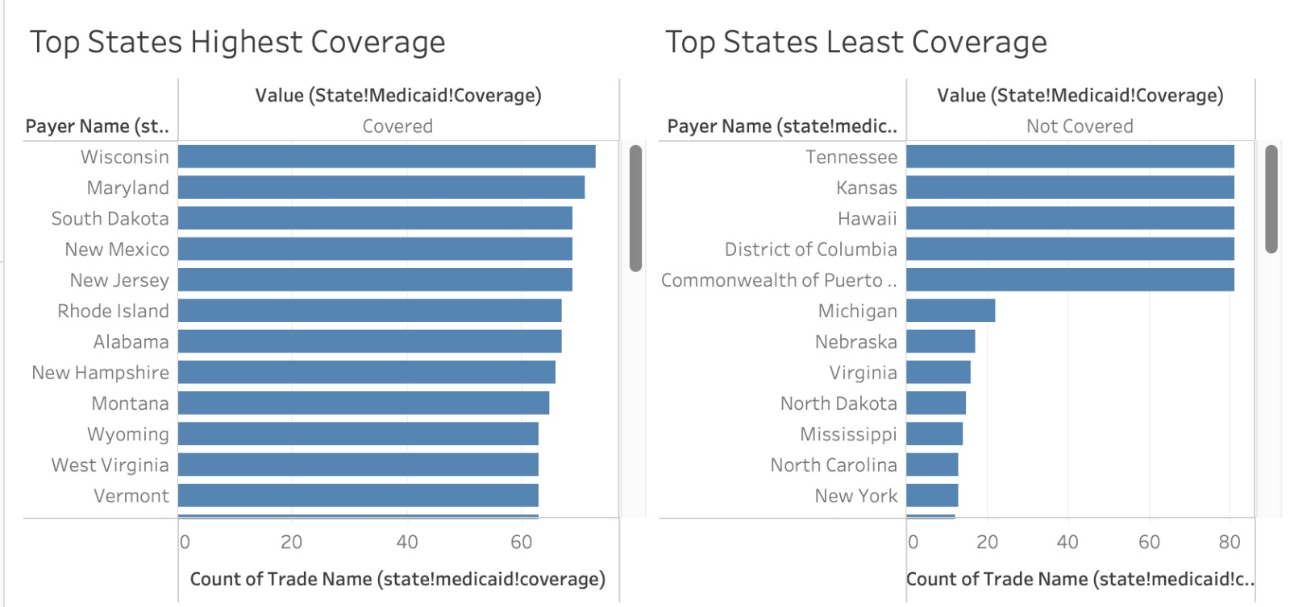

Fig. 24: Highest Coverage and Least Coverage by Payers

1. Coverage status in all the States for the selected drug

This graph/dashboard shows the status for Covered, Covered(PA/ST), Not Covered, Preferred, Preferred(PA/ST) data in the whole US.

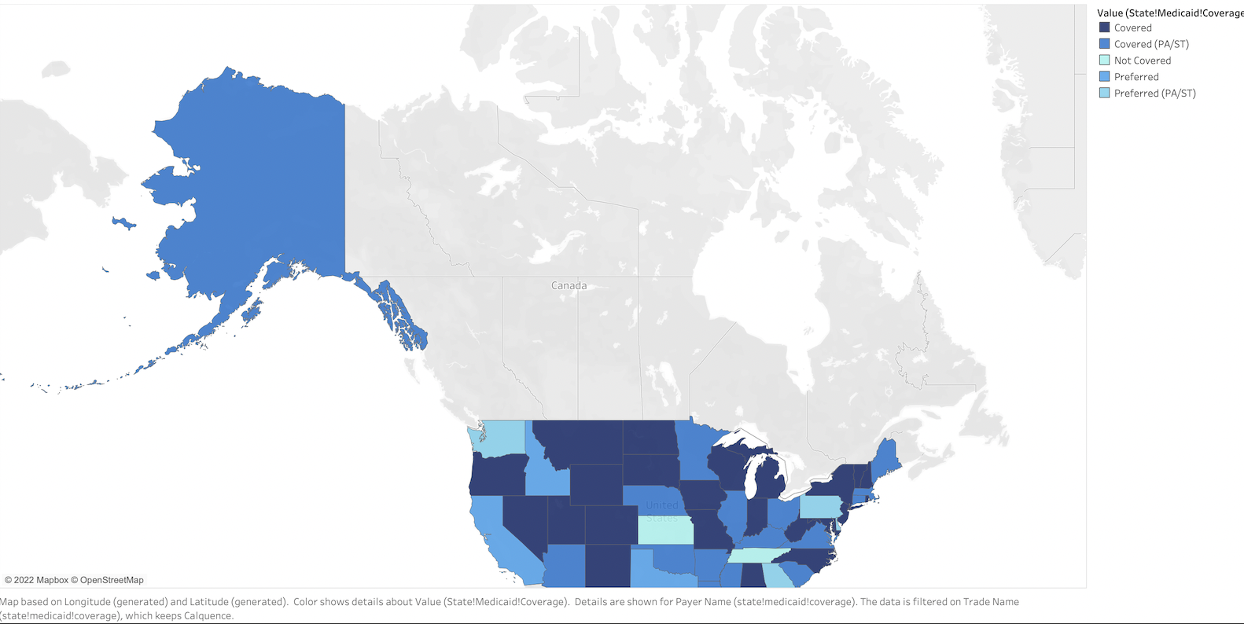

Fig. 25: Coverage status for particular drug

VIII. CONCLUSION

Since its introduction in 2012, the breakthrough designation program has approved the most no. of drugs in 2018, but this count has been declining since then. Higher costs of the drugs and poor reception by the medical coverage from insurance providers may be the reason behind this.

We study the coverage data from Commercial, Medicare, and State Medicaid providers. And find a big discrepancy in the coverage for these listed drugs. Drug Cosela by G1 Therapeutics is covered by most commercial plans, whereas Pluvicto by Novartis is among the top most not covered drugs in the market.

Looking at the State Medicaid data, we find Wisconsin State Medicaid covers all 82 drugs, whereas Tennessee, Kansas, and Hawaii do not cover any of the breakthrough therapies under the State Medicaid program.

Analyzing the Medicare data(Coverage for ages above 65) we find Kaiser Foundation Health plans cover the highest no. of breakthrough drugs. While a high portion of Medicare providers covers these drugs after some restrictions(PA/ST). Toggle the dashboard filters to see variations in the above graphs by varying the Coverage buttons.

IX. REFERENCES

1. Reimers, Nils, and Iryna Gurevych.“Sentence-bert: Sentence embeddings using siamese bert-networks” arXiv preprint arXiv:1908.10084 (2019).
2. *https://www.fda.gov/patients/fast-track-breakthrough-therapyaccelerated-approval-priority-review/breakthrough-therapy*
3. Blumenthal, Gideon M., et al. “Oncology drug approvals: evaluating endpoints and evidence in an era of breakthrough therapies.” The oncologist 22.7 (2017): 762-767.
4. Breakthrough Therapies: *https://friendsofcancerresearch.org/breakthrough-therapies/*
5. Section 111 Valid ICD-10 Diagnosis Codes for NGHP RREs: *https://www.cob.cms.hhs.gov/Section111/assets/section111/icd10.dx.codes.html*
6. Medicare Data CMS Program Statistics: https://data.cms.gov/search?keywords=Medicare
7. CMS Gov Research, Statistics, Data and Systems: *https://www.cms.gov/Research-Statistics-Data-and-Systems/Research-Statistics-Data-and-Systems*
8. Data and Systems - Medicaid.Gov : *https://www.medicaid.gov/medicaid/data-systems/index.html*
9. Projections Of National Health Expenditures And Health Insurance Enrollment: Methodology And Model Specification: *Reports/NationalHealthExpendData/NationalHealthAccountsProjected*
10. Centre for Disease Control and Prevention: *https://wonder.cdc.gov/*
11. Reverses Course on Medicare Coverage of Breakthrough Medical Devices: *https://www.ropesgray.com/en/newsroom/alerts/2021/October/CMS-Reverses-Course-on-Medicare-Coverage-of-Breakthrough-MedicalDevices*
12. 10 most expensive drugs in the US, Period: *https://www.goodrx.com/healthcare-access/drug-cost-and-savings/most-expensive-drugs-period*
13. Prior Authorization and Step Therapy Programs:

*https://www.bcbsil.com/provider/pharmacy/pharmacy-programs/pa-st-programs#:~:text=Prior%20authorization%20(PA)%20and%20step,when%20certain%20conditions%20are%20met*

1. Formularies: *https://www.healthaffairs.org/do/10.1377/hpb20171409.000177/*
2. International HealthCare system profiles - United States: *https://www.commonwealthfund.org/international-health-policy-center/countries/united-states*
3. FDA’s Breakthrough Therapy Designation: *https://www.pharmexec.com/view/fda-s-breakthrough-therapy-designation*
4. Precision Medicines’ Impact on Orphan Drug Designation: *https://ascpt.onlinelibrary.wiley.com/doi/full/10.1111/cts.12667*
5. Breakthrough Therapy Designation Market Size, Share & Trends Analysis Report By Application (Oncology, Infectious Diseases, Rare Diseases, Autoimmune Diseases, Pulmonary Diseases, Neurological Disorders), And Segment Forecasts, 2018 - 2025: *https://www.grandviewresearch.com/industry-analysis/breakthrough-therapy-bt-designation-market*
6. Section 2: Morbidity Frequency Measures: *https://www.cdc.gov/csels/dsepd/ss1978/lesson3/section2.html#:~:text=Incidence%20refers%20to%20the%20occurrence,cases%20per%20unit%20of%20population.*
7. Coverage dataset:

*Formularylookup.com*

1. International Health Care System Profiles United States: *https://www.commonwealthfund.org/international-health-policy-center/countries/united-states*
2. Prior Authorization: *https://www.amcp.org/about/managed-care-pharmacy-101/concepts-managed-care-pharmacy/prior-authorization#:~:text=Prior%20authorization%20requires%20the%20prescriber,of%20the%20pharmacy%20benefit%20plan.*
3. How does step Therapy work?: *https://www.bcbsm.com/index/health-insurance-help/faqs/plan-types/pharmacy/what-is-step-therapy.html*
4. Formularies: *https://www.healthaffairs.org/do/10.1377/hpb20171409.000177/*
5. What is ICD-10: *https://www.aapc.com/icd-10/#:~:text=Used%20for%20medical%20claim%20reporting,and%20diseases%2C%20and%20social%20circumstances.*
6. World Population Review of 2022: *https://worldpopulationreview.com/state-rankings/medicaid-enrollment-by-state.*

# X. ACRONYMS

1. The acronyms ICD-9/ICD-10 are used in medical fields that stand for International Classification of Diseases, ninth/tenth revision.

In order to process claims Medicare, ICD diagnosis codes submitted by RREs on Section 111 Claim Input Files are used.

# 

# 

# XI. APPENDIX

PROJECT DATA VISUALIZATION DASHBOARDS

1. Data Connectivity

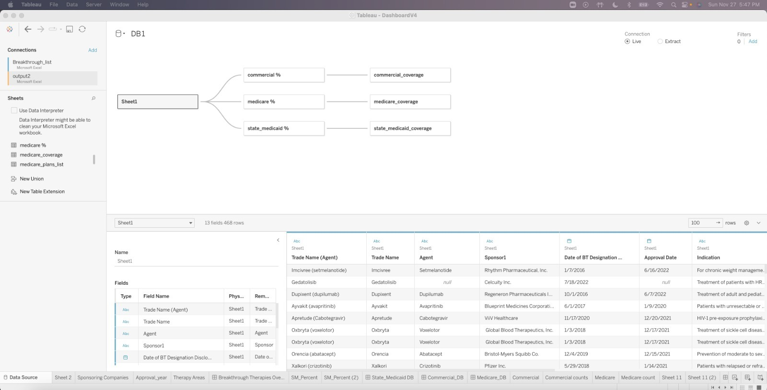

Fig. 26: Data Connectivity

1. Breakthrough Therapies Overview Dashboard

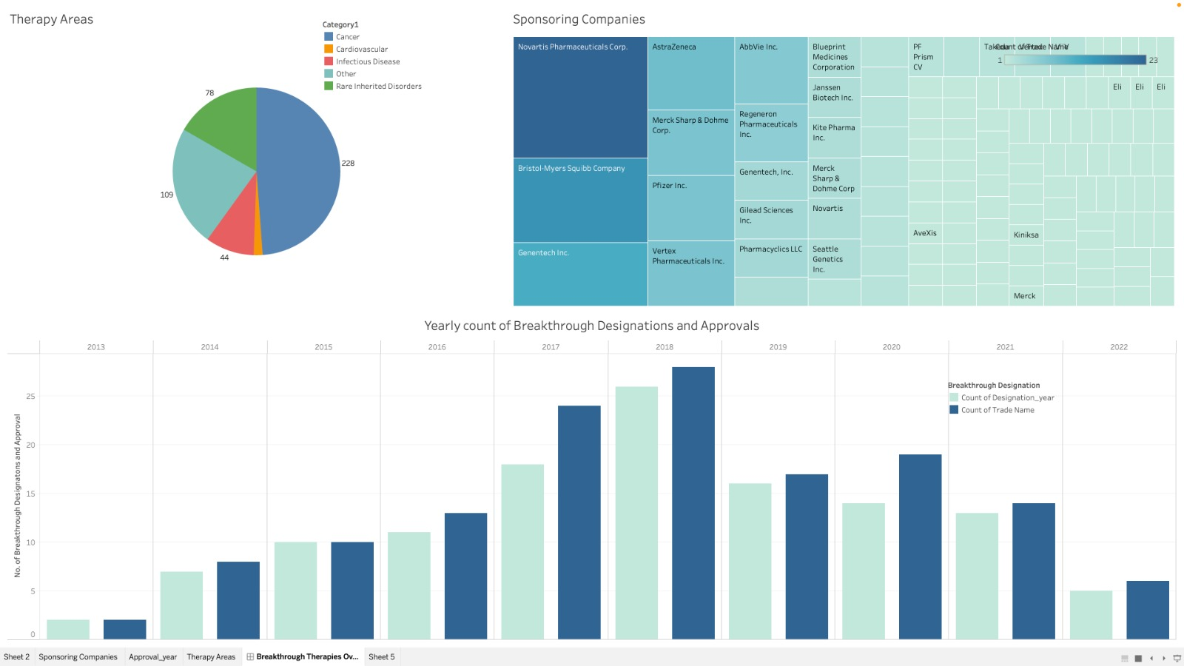

Fig. 27: Dashboard 1- Yearly Count of Breakthrough Designations and Approvals

### 

Fig. 27: Sponsoring Companies based on count of sponsored drugs

1. Commercial Coverage Dashboard



Fig. 28: Dashboard 2 - Commercial Coverage by Insurance Providers

1. Medicare Coverage Dashboard:

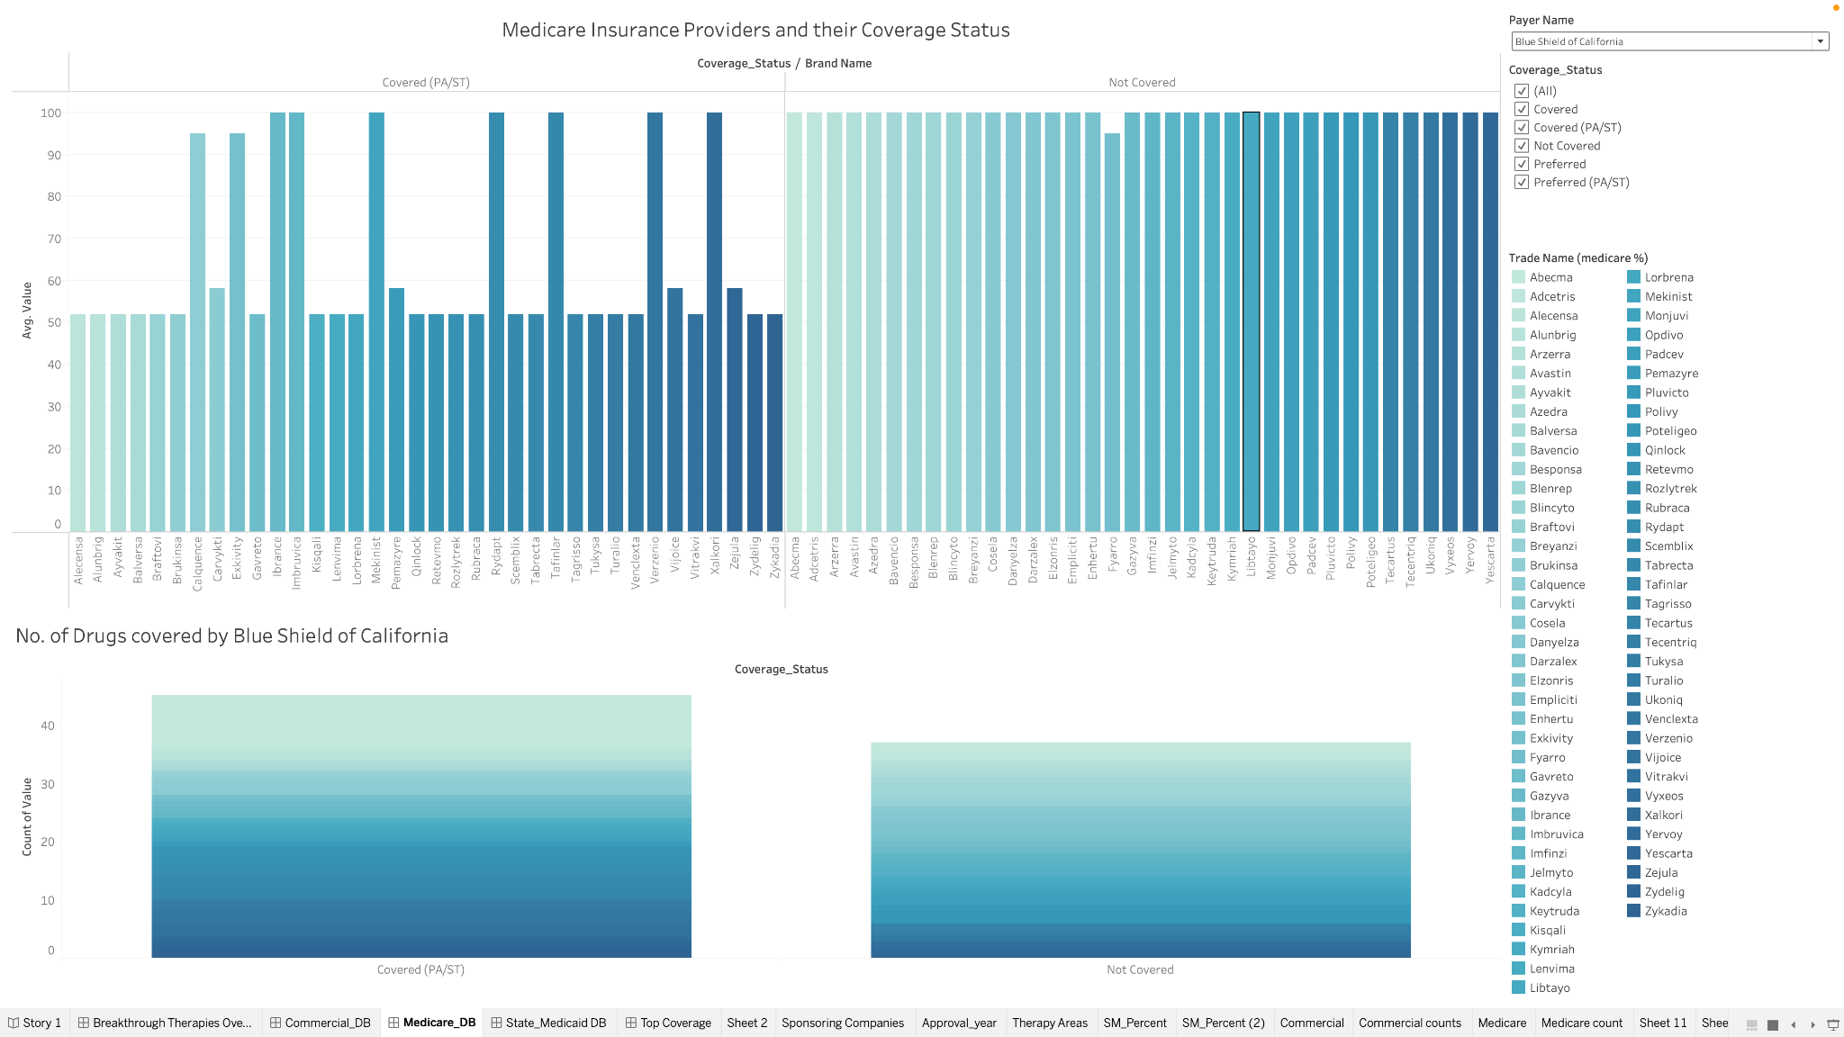

Fig. 29: Medicare Coverage Dashboard

1. State Medicaid % Coverage Dashboard for all trades:



Fig. 30: State Medicaid % Coverage Dashboard for all trades

1. Top insurers, brands and States analysis dashboard

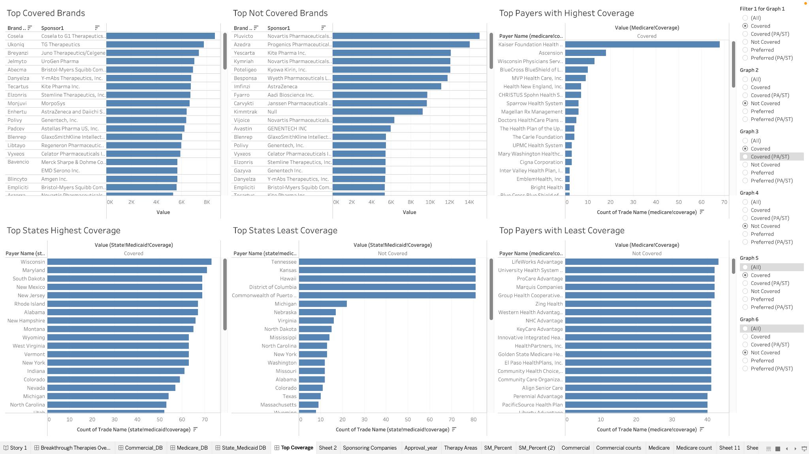

Fig. 31: Top insurers, brands and States analysis dashboard